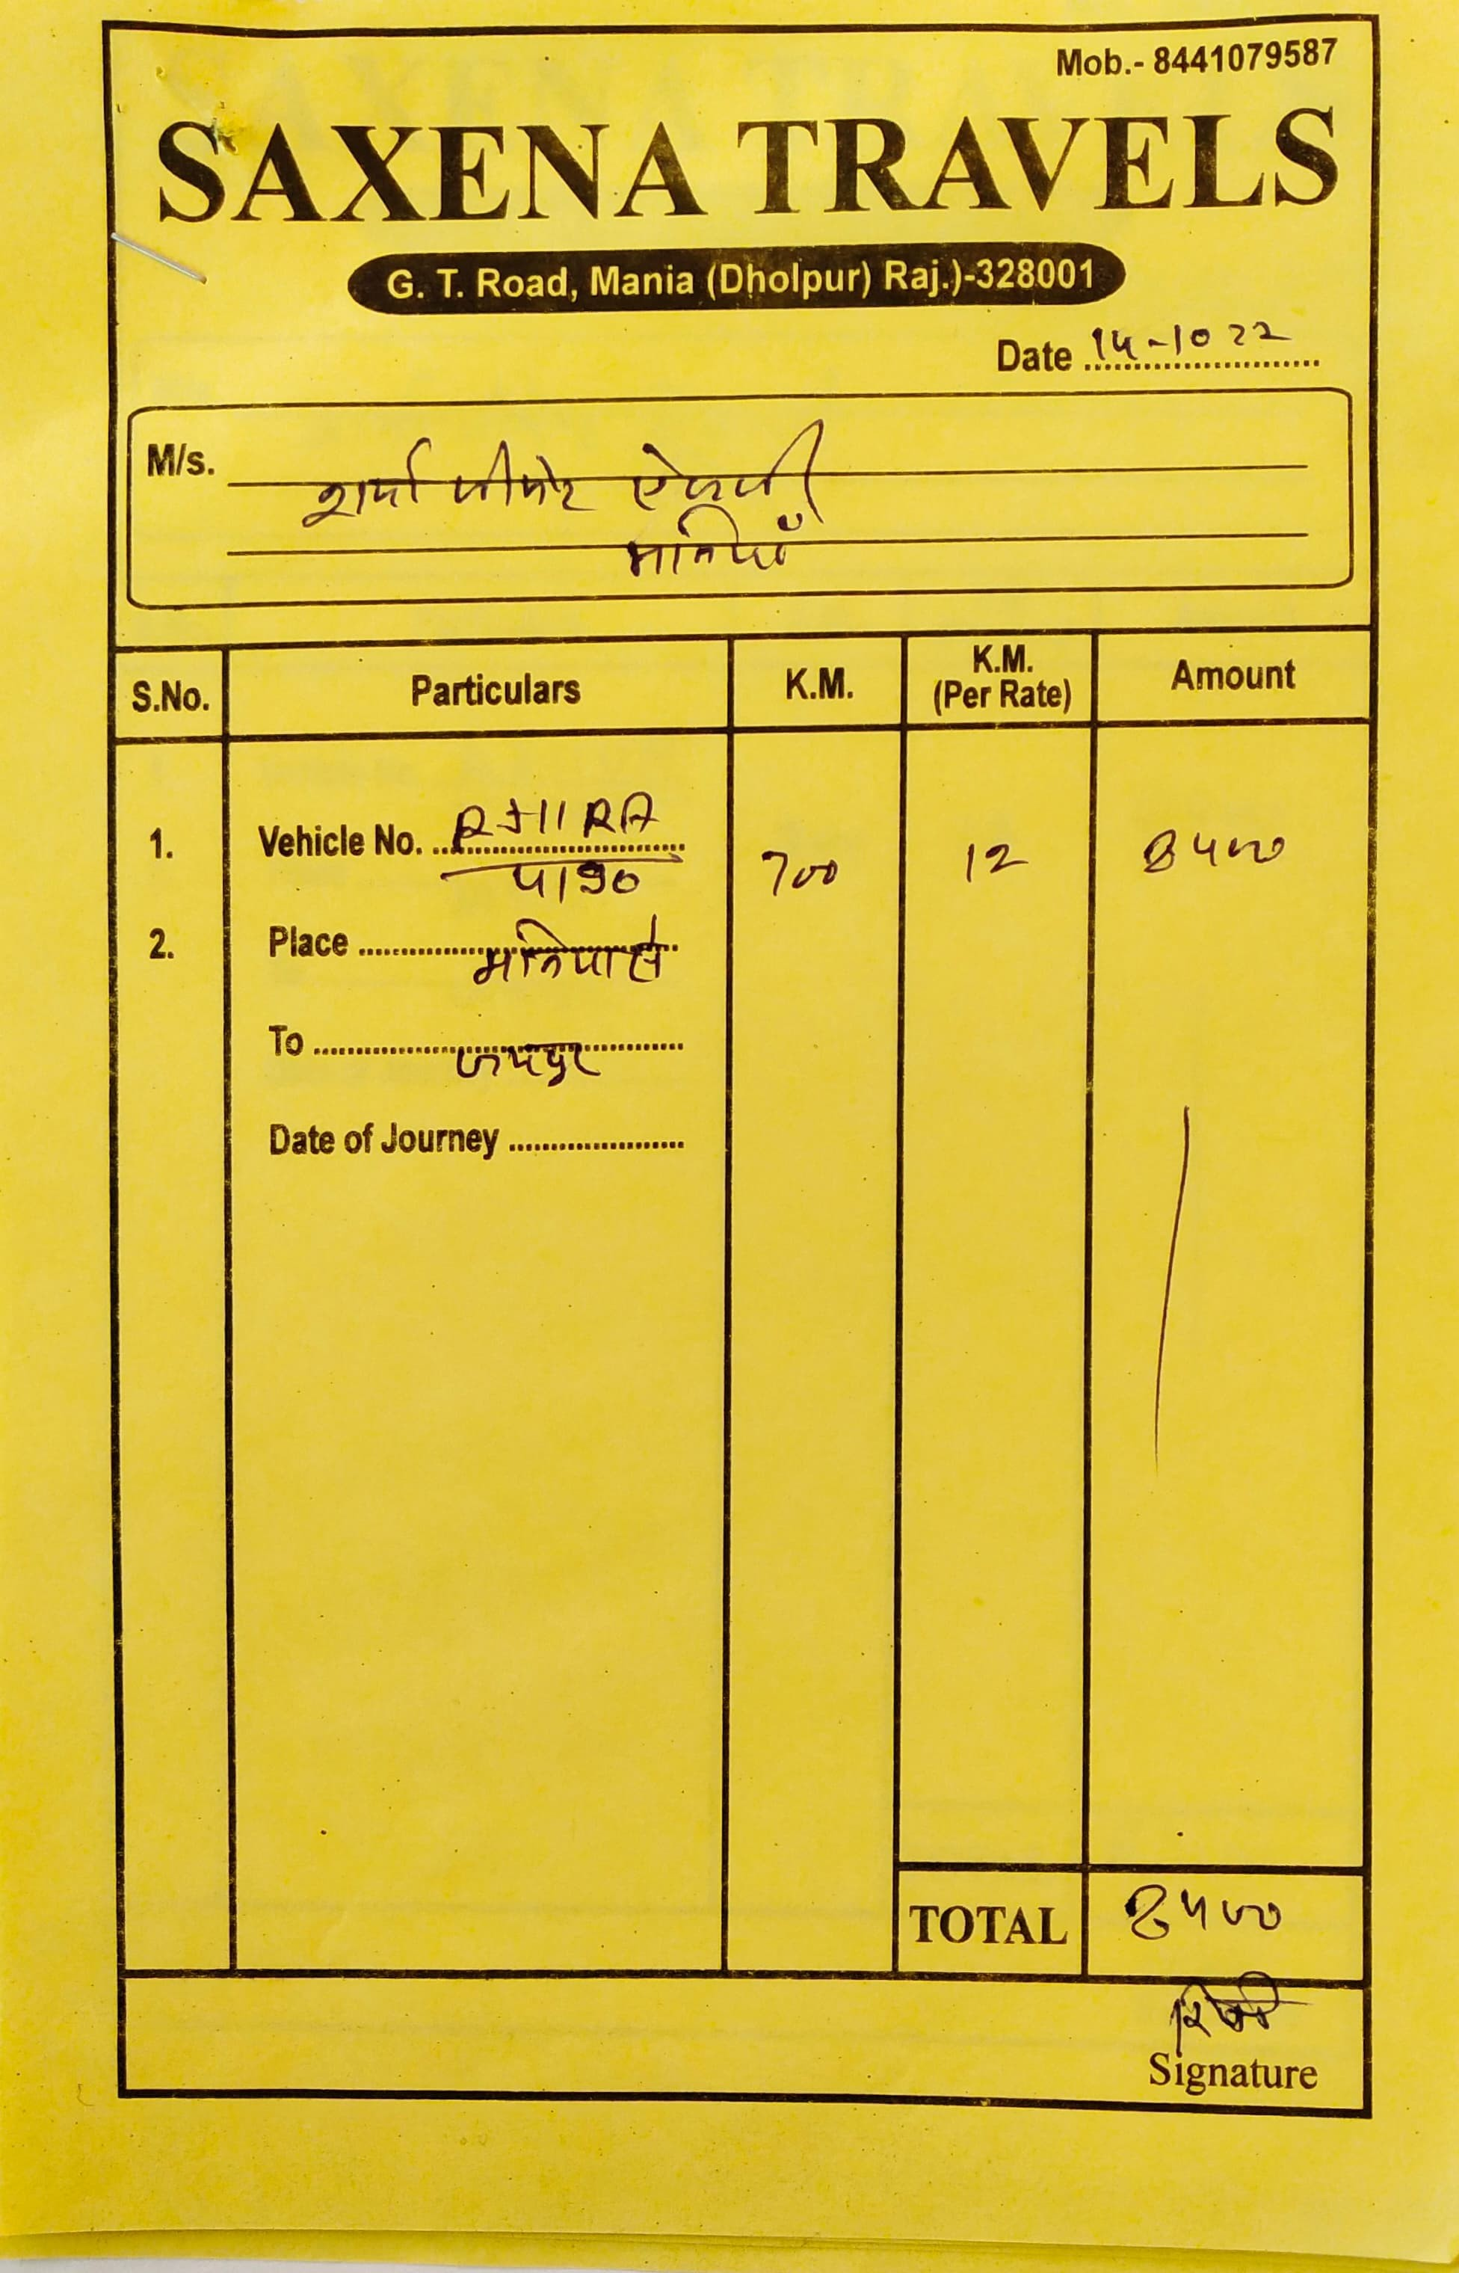

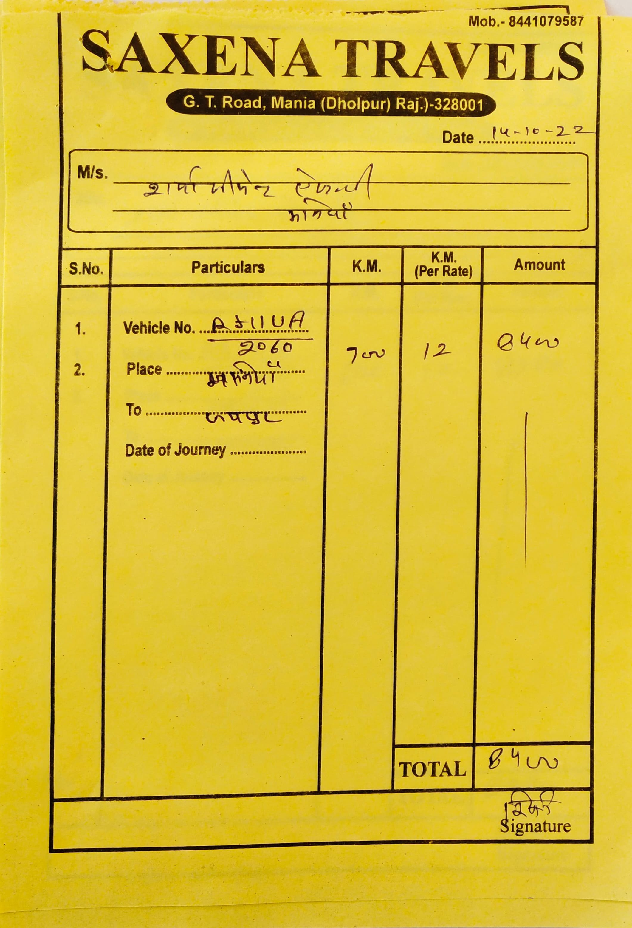

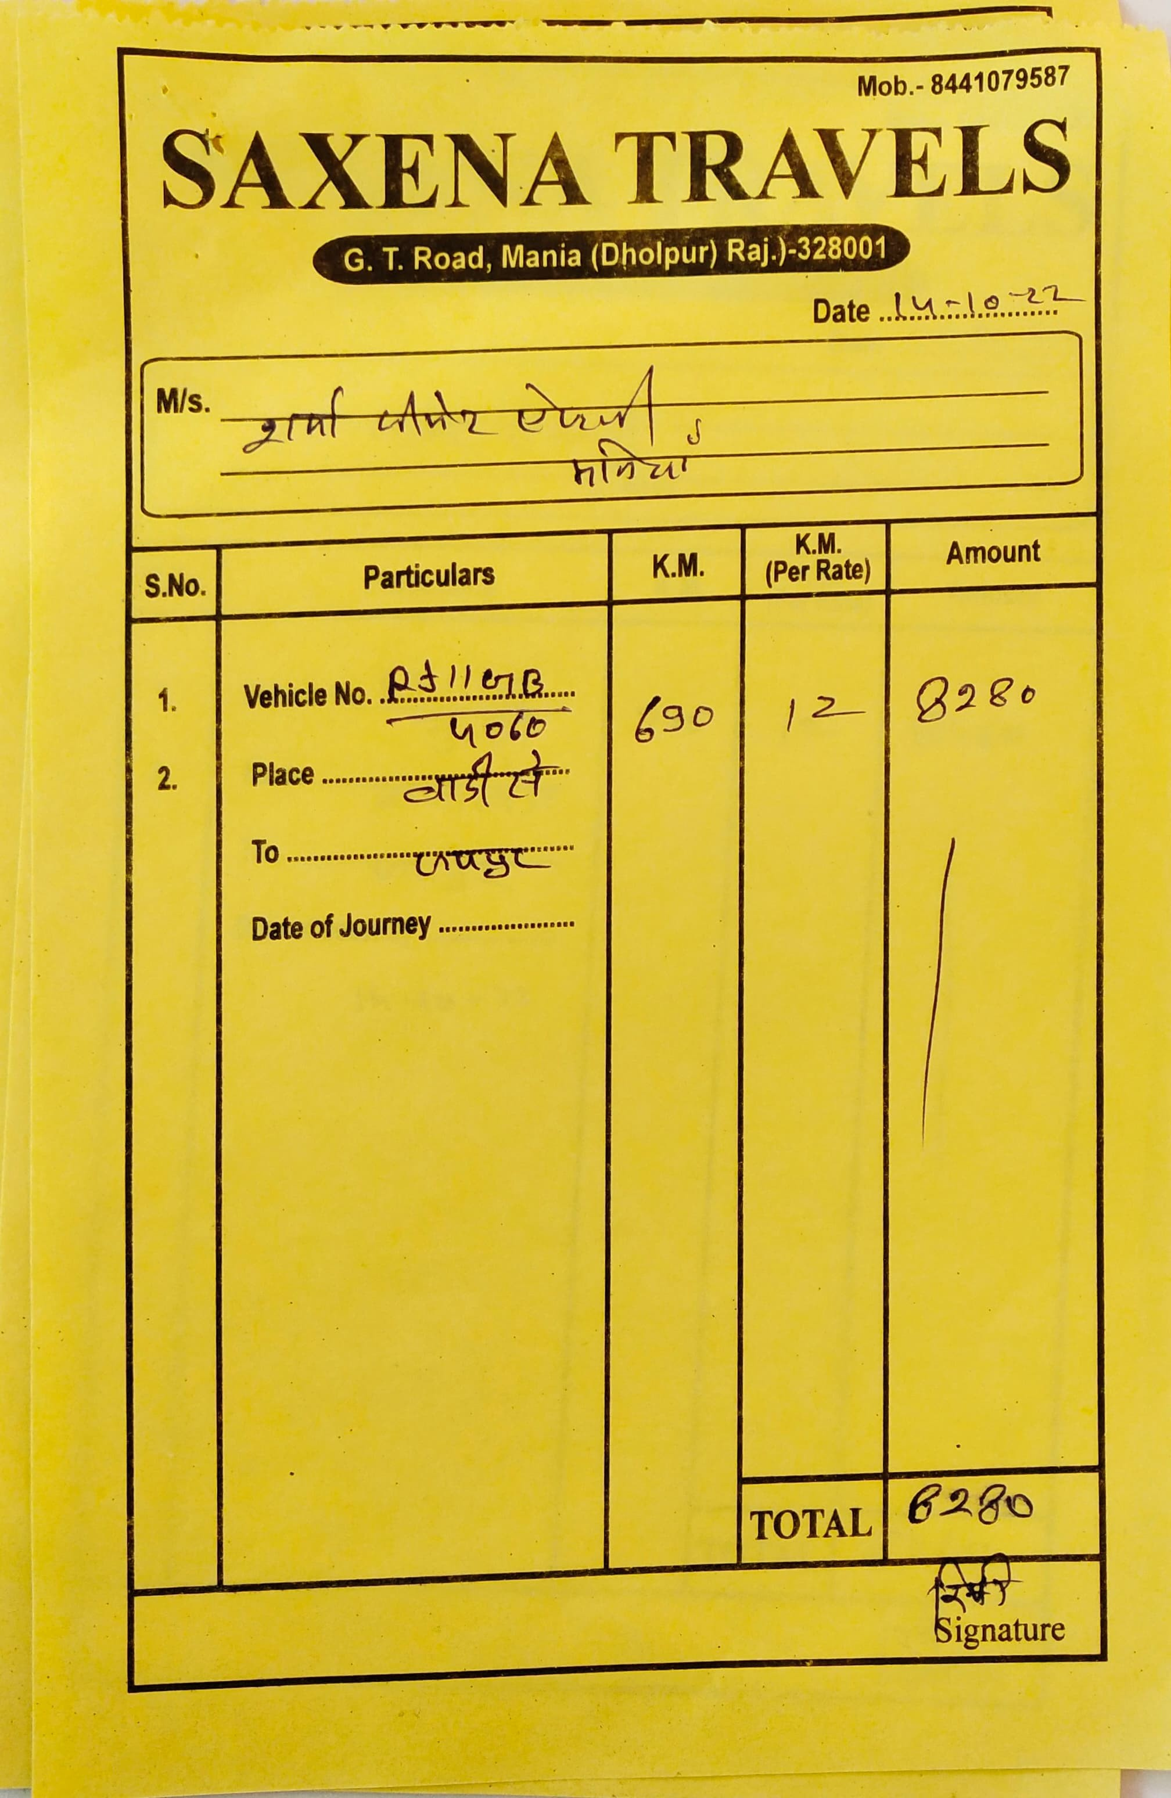

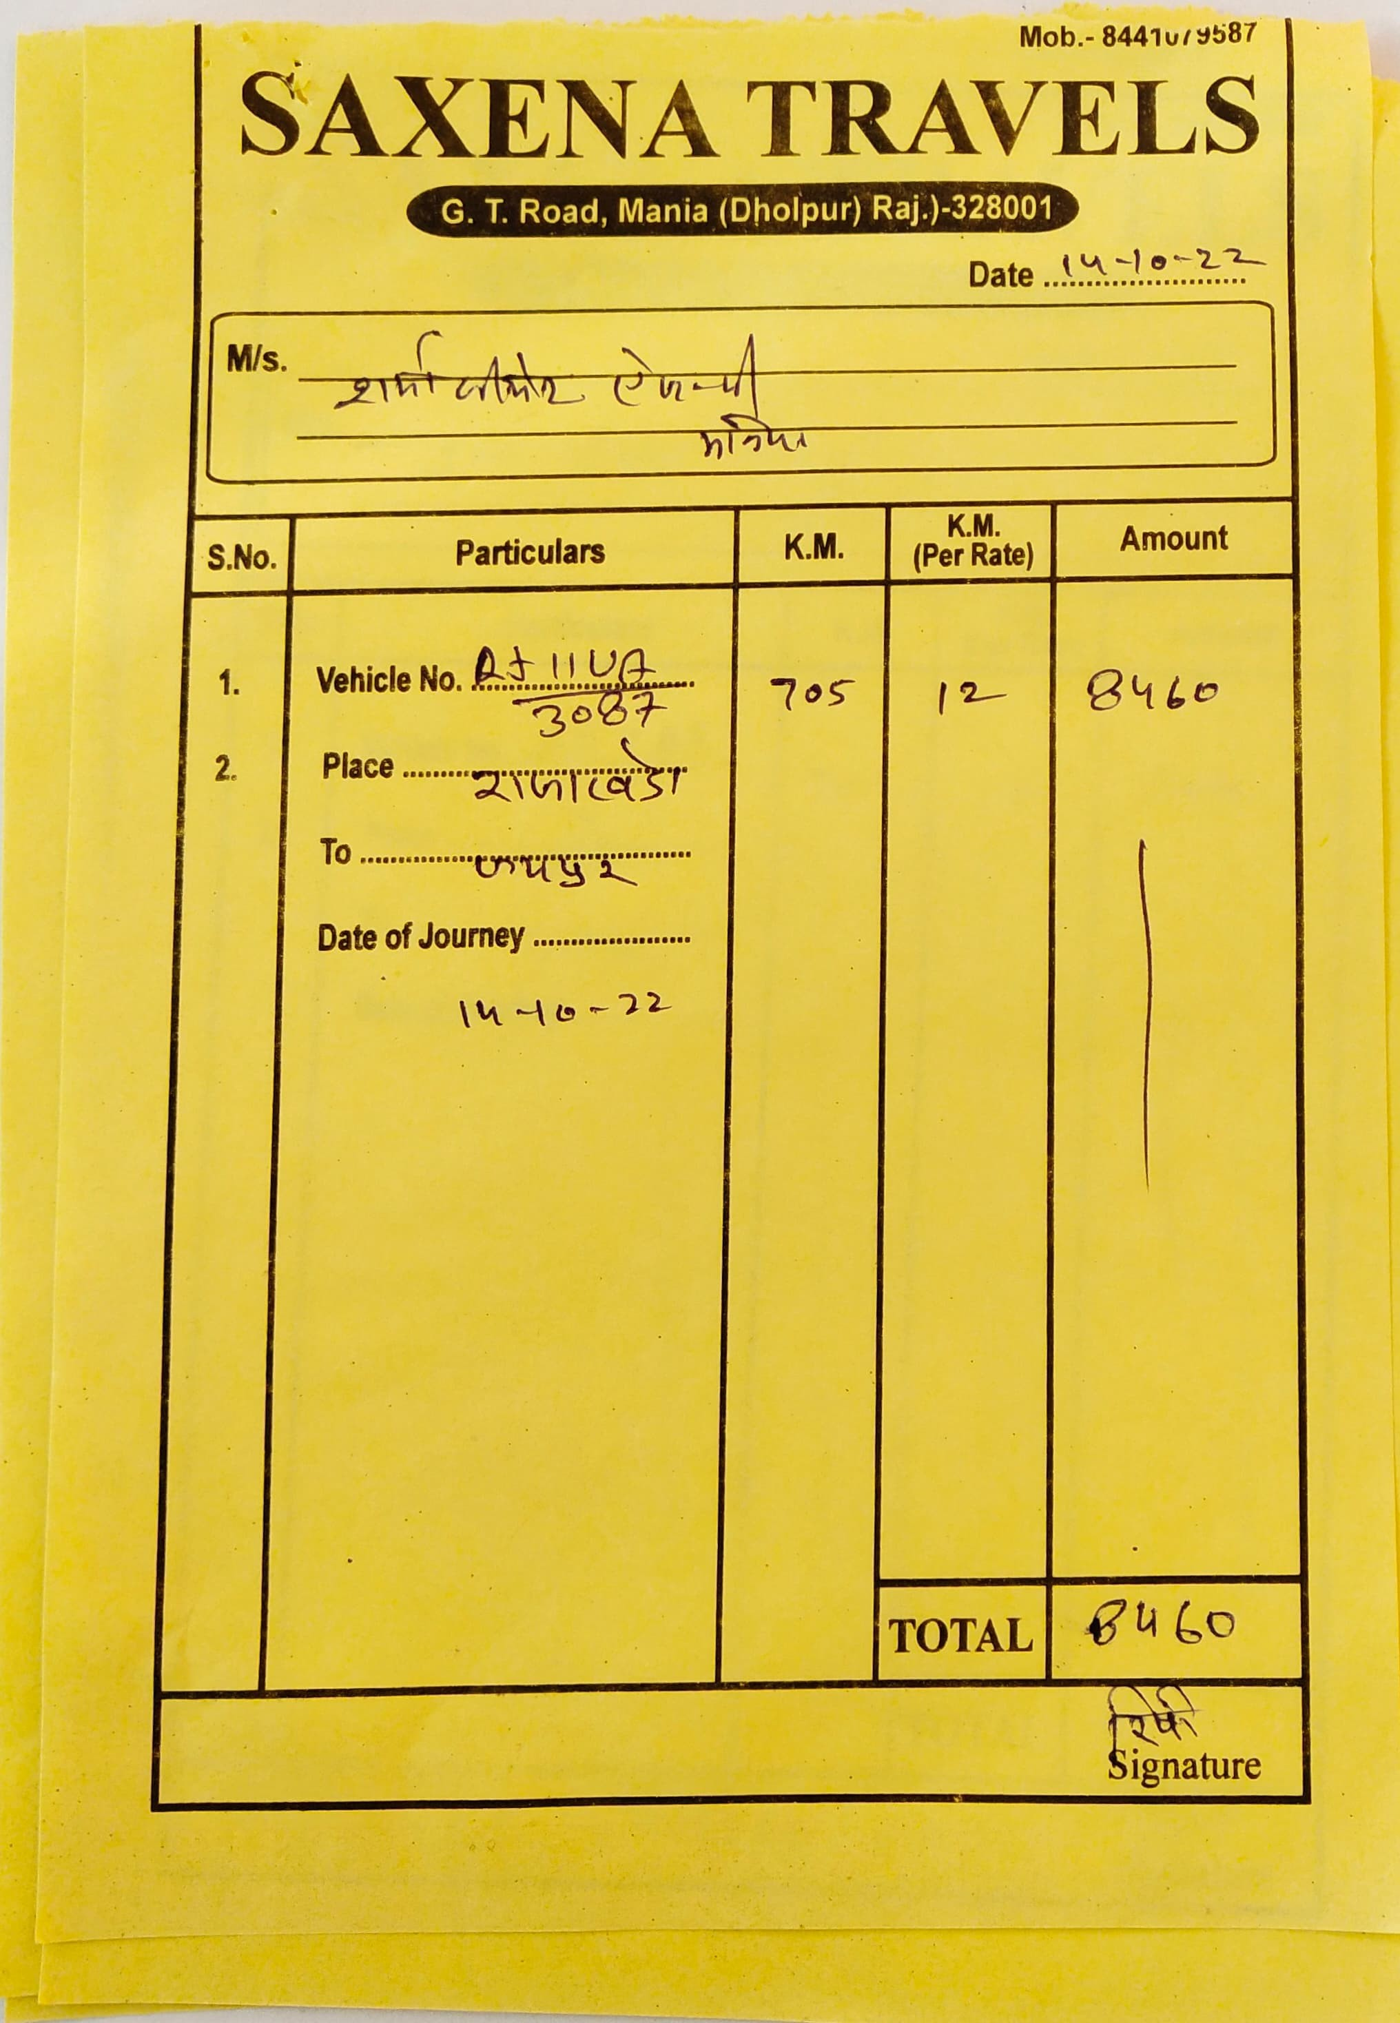

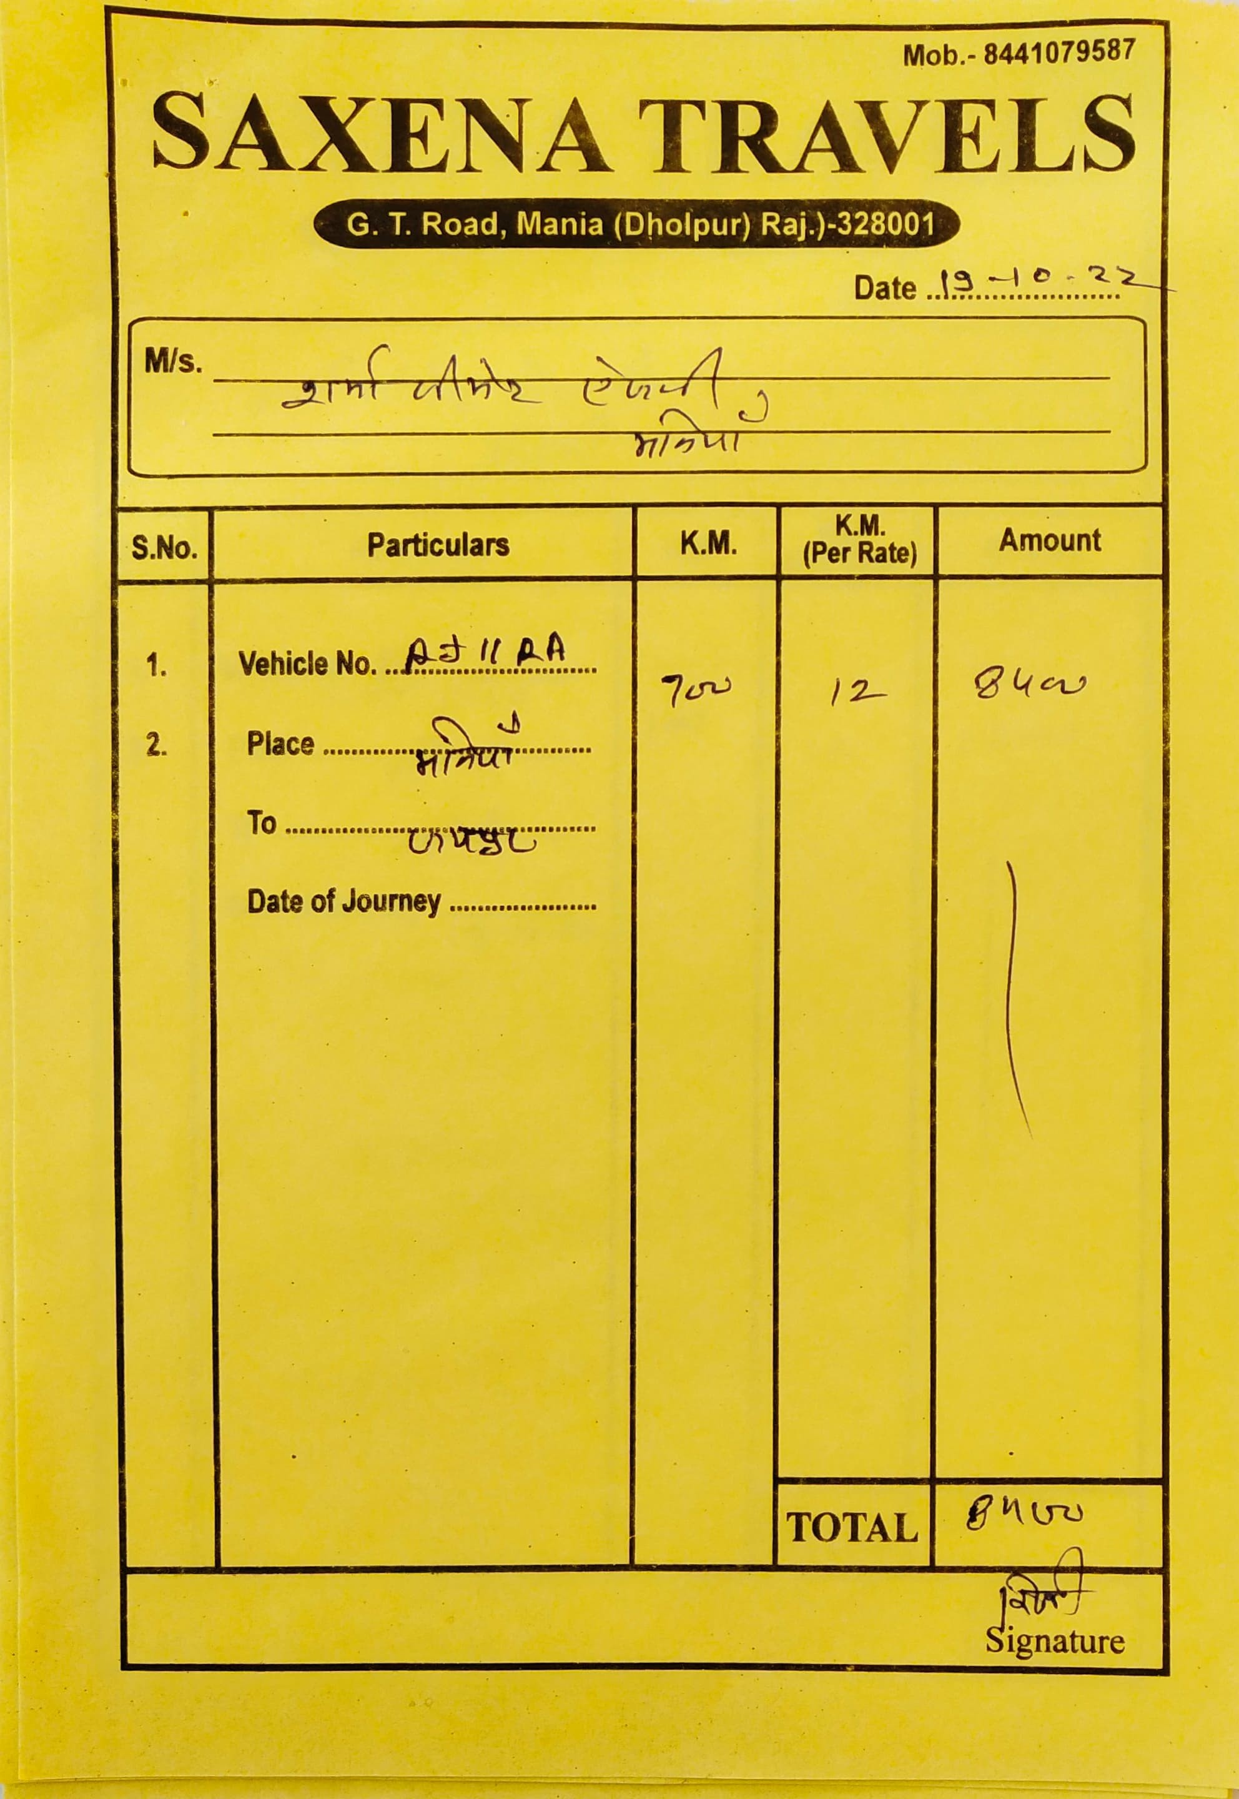

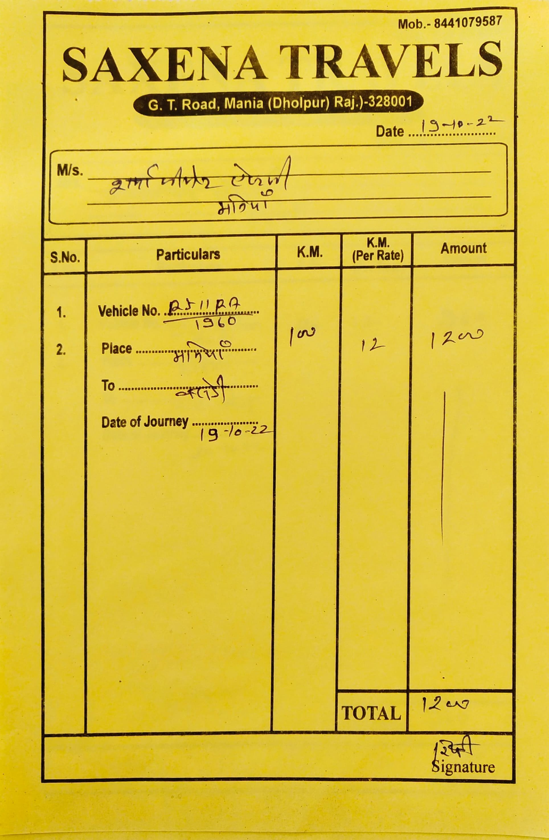

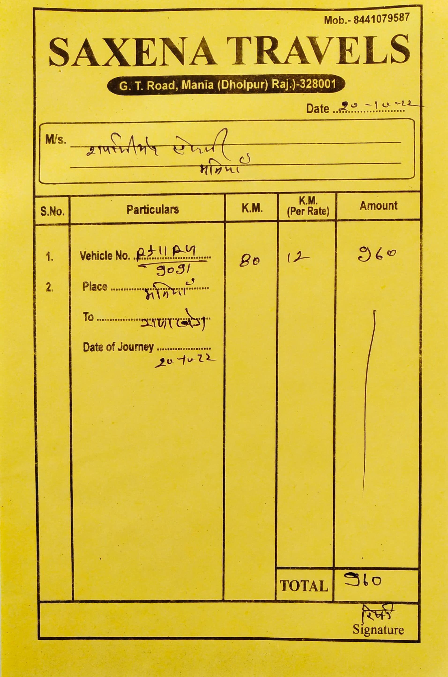

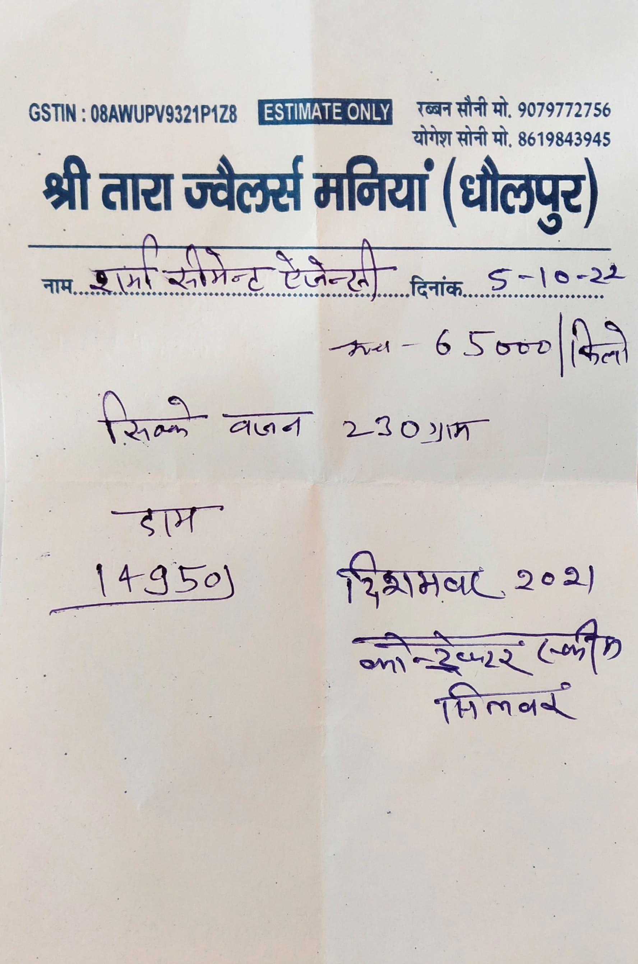

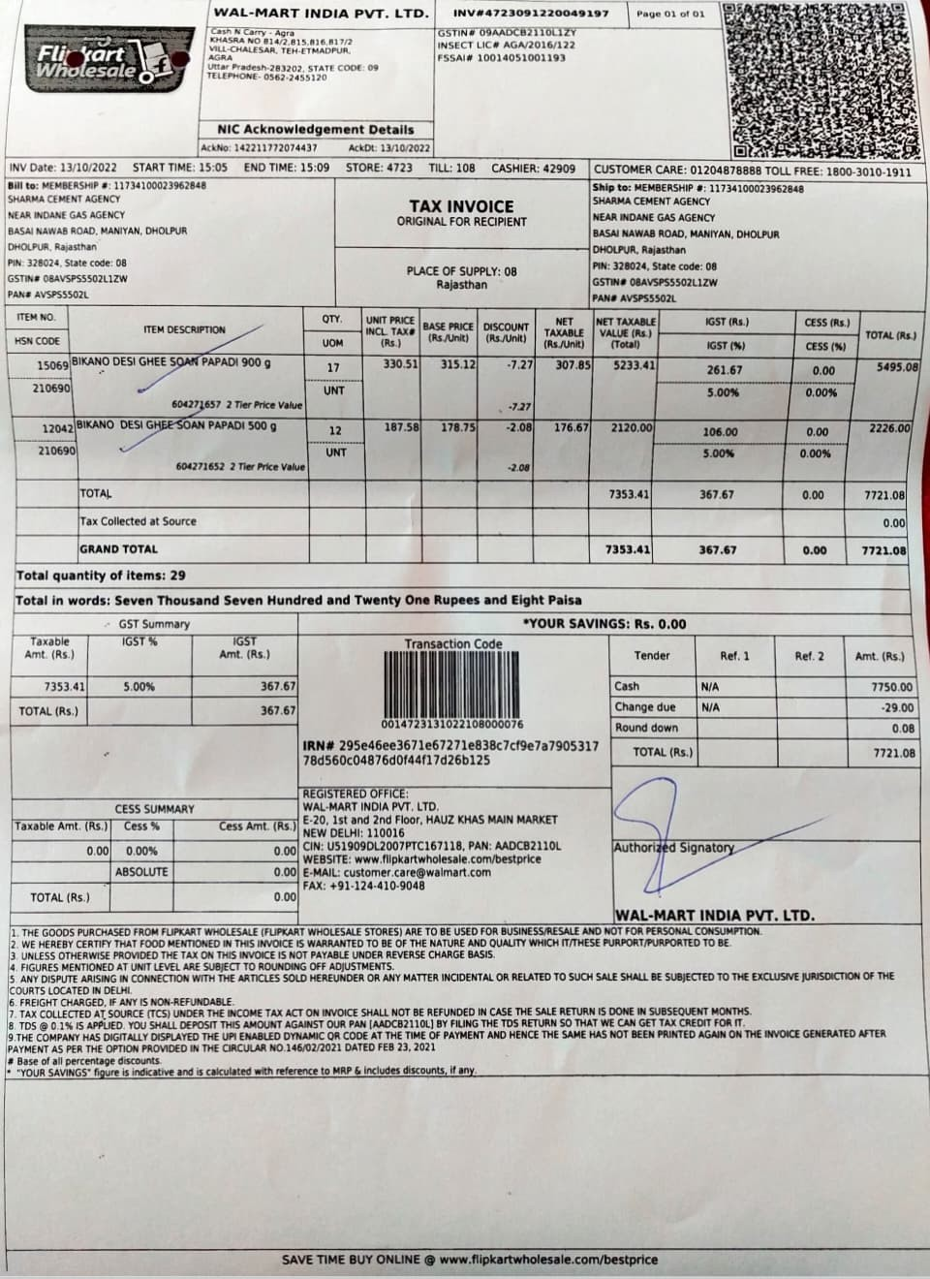

To whomever ft may concern

*We Els.* SHAAMA *CEMENT ACen* having place of business at NEAR INDANE GAS AGENCY, BASAI NAyyAB ROAD, NANIYAN, DHOLPUR, DHO@UR. Rajasthan, PIN: 328024, State code: 08 wish to undertake the following:

- Goods purchased from Walmart India Private Limited Cash N Carry - Agra, KHASRA NO

814/2,815,816,817/2

VILL-CHALESAR. TEH-ETMADPUR., AGRA-2B3202, 09, against Invoice No.

#4723091220049197 dated 13.10.2022 would be transported and consumed outside Uttar

Pradesh.

In case there Is any GST liability arising to walmart India Private Limited due to failure of movement of goods by the undersigned, the same shall be made good to the former along with interest and penalty.

For SHARMA CEMENT AGENCY

NEAR INDANE GAS AGENCY. BASAI NAWAB ROA0, MANfYAN, DHOLPUR, OHOLPUR, Rajasthan,

PIN: 328024. State code: 08

*Signature*

# 13/10/2022

08ABGPT6910P1ZY TAX INVOICE

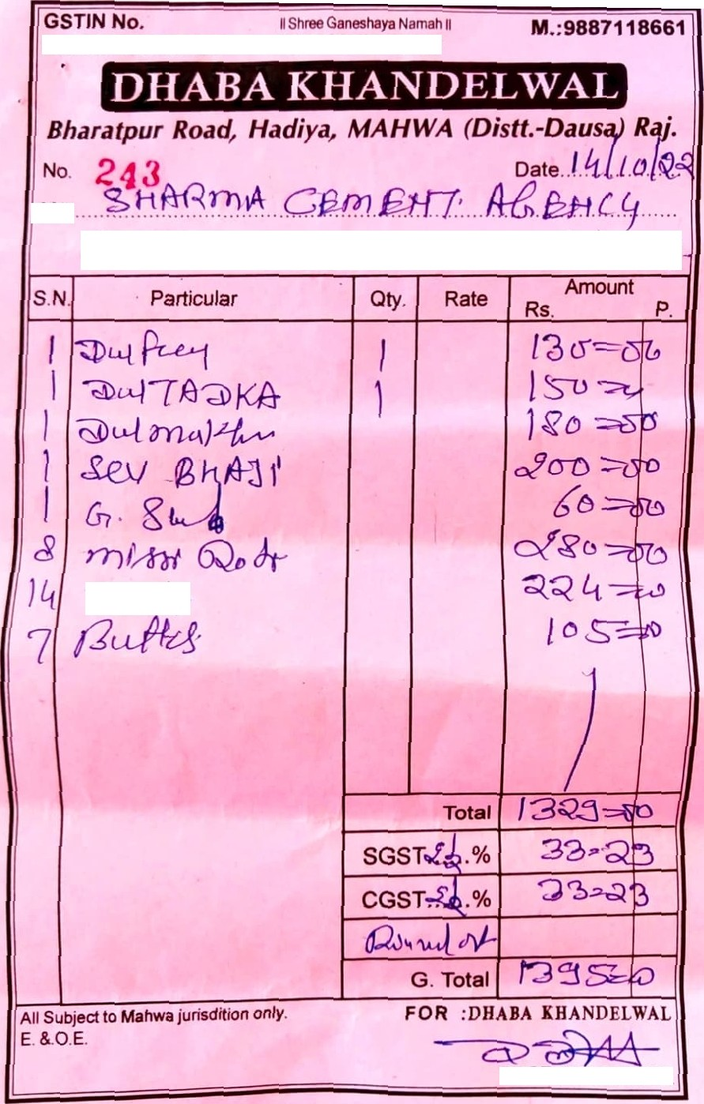

M/s

# PROP.Z MANAGE R

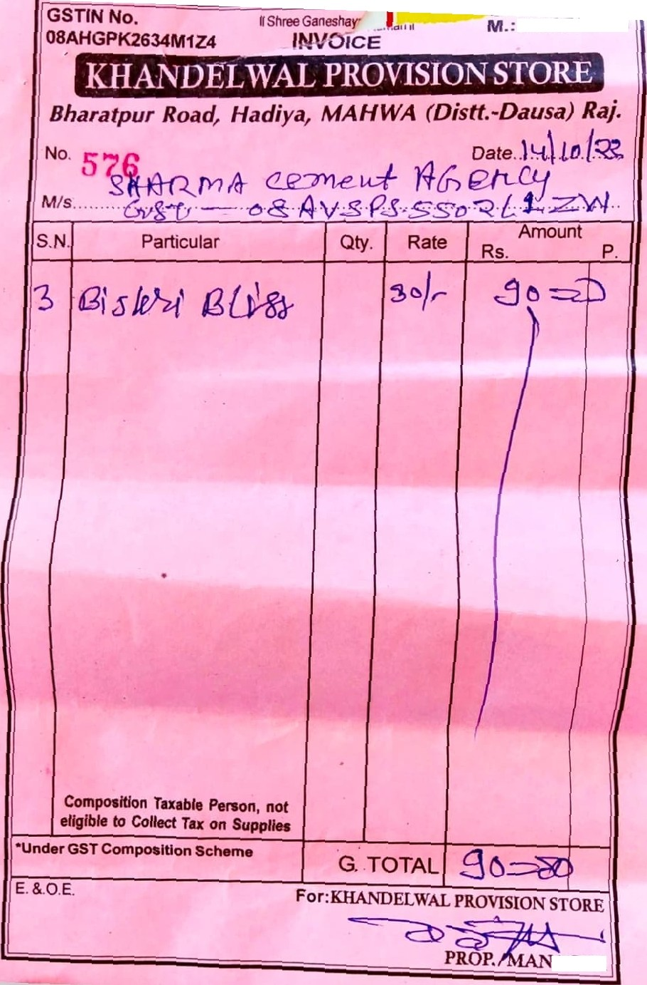9829778ben

AGER

1/55, Johari Bazar, AGFbq,-282 003 Mob.: 9368031119

Dated )..

Recip\ant / *8uye7s* Call..

Address

(in case of being reg. dealer)

PARTICULARS

Rs.

Amount

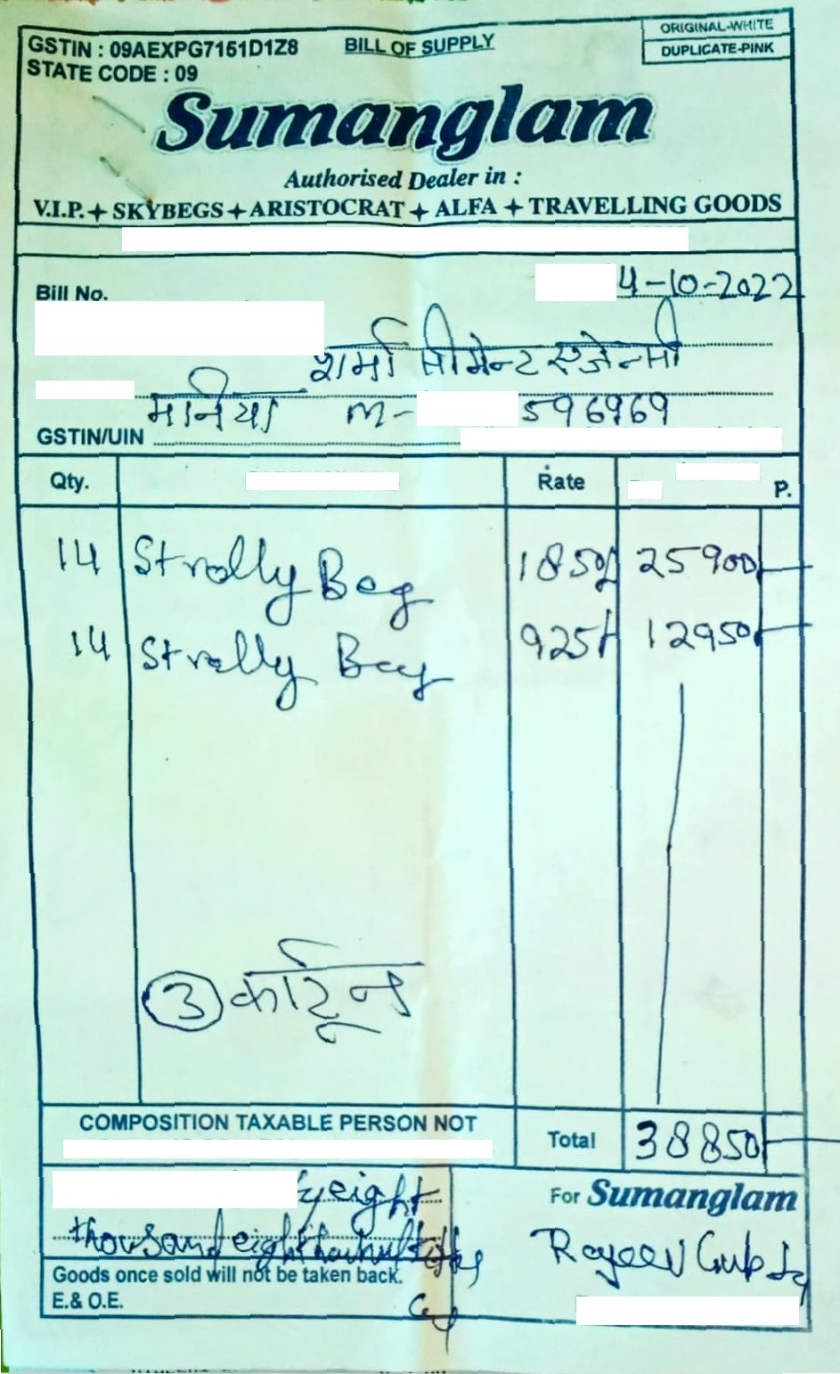

ELIGIBLE TO COLLECT TAX OH SUPPLIES

Rupees in wo‹ds V

I” P Uth. Sig Fl ato ry

